

**Subject:**

**Visual Programming.**

**Roll No:**

**233579.**

**Department:**

**BSCS-A.**

**Task:**

**Assignment-01.**

**Submitted To:**

**Aatka Ali.**

**Submitted By:**

**Zahid Zafar.**

**3x3x3 Matrix**

**Code:**

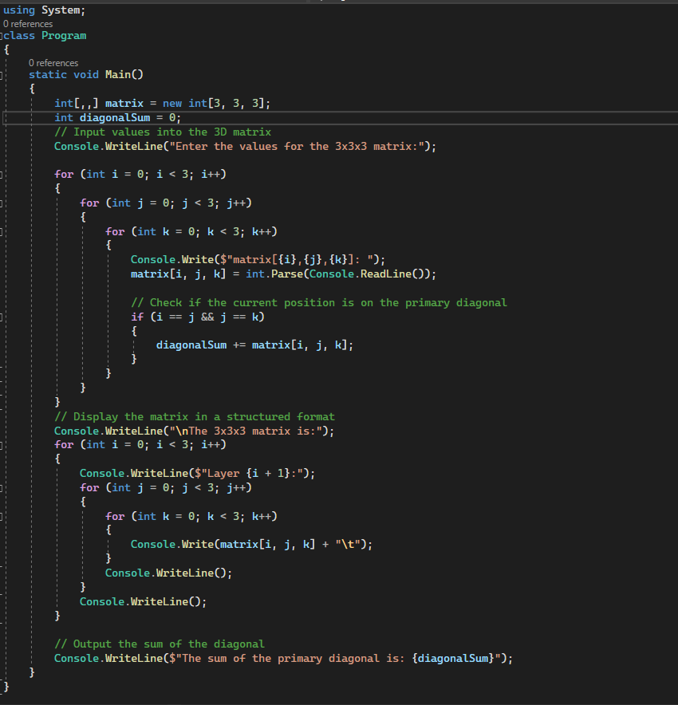

**OUTPUT:**

